Multitenant RAG Architecture Design
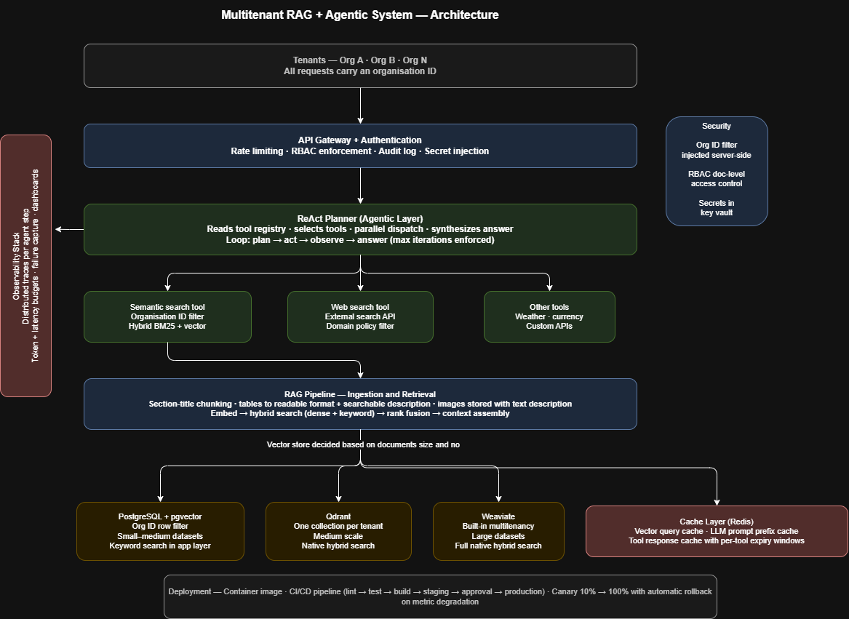

1. Data Ingestion & Indexing
Documents are chunked at section title boundaries rather than fixed character counts, preserving document structure. Within each chunk, content types are handled individually: tables are converted to a readable text format and a searchable description of the full table is generated so it is discoverable via semantic search even when no query term matches a cell value. Images are stored with a generated text description that is embedded and indexed, making visual content semantically searchable. The original image and table is returned to the language model at retrieval time for full context.
Retrieval uses hybrid search: dense vector search for semantic similarity and keyword-based sparse search for exact terms, product codes, and identifiers. Results are merged using rank fusion without manual score tuning.
Vector store is chosen by dataset size and complexity per tenant:
Scenario | Store | Tenancy model | Trade-off
Small–medium data per org | PostgreSQL + pgvector | Org ID column filter on every query | Simple, low infra cost; keyword search weaker, compensated in app layer
Medium scale, clean isolation | Qdrant | One collection per tenant | Native hybrid search; slightly more infra to manage
Large datasets, strict compliance | Weaviate | Built-in multi-tenancy | Best isolation and hybrid search; highest operational cost

2. Agentic Layer
The planner implements a ReAct/Agentic loop via the language model's function-calling interface:
receive query → decide tools → call tools (independent tools run in parallel) → observe results → produce answer.
A maximum iteration limit prevents runaway loops; hitting it returns a graceful partial answer. The most critical engineering surface is tool description quality. each description must state clearly when to use the tool and when not to, because this is what the planner reads to route correctly.

Query type | Tools called
Internal policy or document question | Semantic search only
Real-time external data (weather, rates) | Dedicated external tool
Current events not in the corpus | Web search only
Internal data plus market context | Semantic search + web search in parallel

3. Cost, Latency & Caching
Three cache layers:
(1) Prompt cache: long system prompts and repeated document blocks pinned to the provider's prompt cache, reducing prompt token cost on repeated queries.
(2) Vector query cache: same organisation, same query skips embedding and search entirely; cache key includes org ID and normalised query, invalidated on document update.
(3) Tool response cache: external tool results cached with per-tool expiry windows sized to how quickly the data changes (e.g. weather shorter, web results longer).
Every agent step is timed and token counts are captured from the model response. Structured output includes per-step latency and token usage, feeding cost dashboards and per-tenant billing.

4. Security & Multitenancy
Every vector search includes a mandatory org ID filter injected server-side at the retrieval layer not in the application layer. A query cannot reach another tenant's data. Within a tenant, RBAC resolves the user's permitted document IDs before retrieval and applies them as an additional filter, giving document-level access control. Every agent invocation is written to an append-only audit log capturing org ID, user ID, query, tools called, latency, and token usage, retained 90 days.

5. Observability
Each agent run produces a distributed trace with one span per step (planner, each tool call, synthesis), exported to an LLM-native observability tool (Langfuse preferred open-source, self-hostable; LangSmith as alternative) with a standard protocol bridge to Grafana.
Key metrics: agent latency, token usage by tenant and cache hit status, tool error rate by tool name. Failed runs are written to a failures table with the full trace so engineers can replay against a patched configuration without re-triggering the user request.

6. Deployment
Service is packaged as a single container image (minimal base, pinned dependencies, non-root user) deployed on Azure Container Apps or equivalent.
CI/CD pipeline: lint → unit tests → build image → staging deploy → integration tests → manual approval → production.
Releases use a canary strategy: new version takes 10% of traffic, metrics monitored for 30 minutes, then promoted to 100% or auto-rolled back. Canary is preferred over blue/green because it avoids running two full environments simultaneously and provides real production signal on subtle quality regressions rather than just uptime signals.

